Job No:5

Job Name :CSS

Input:

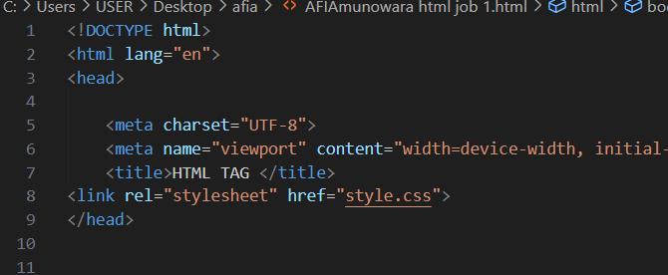

Output:

